Given an array of points on the **X-Y** plane points where points[i] = [xi, yi], return *the area of the largest triangle that can be formed by any three different points*. Answers within 10-5 of the actual answer will be accepted.

**Example 1:**

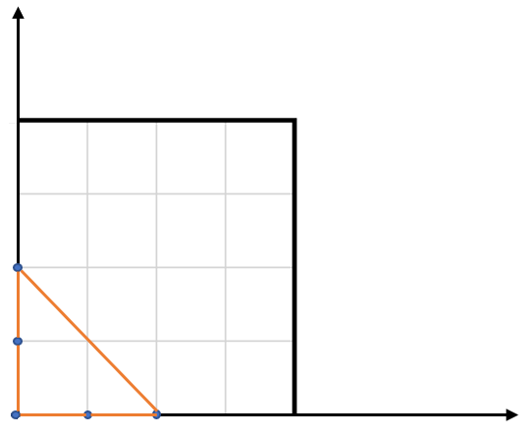

Input: points = [[0,0],[0,1],[1,0],[0,2],[2,0]]  
Output: 2.00000  
Explanation: The five points are shown in the above figure. The red triangle is the largest.

**Example 2:**

Input: points = [[1,0],[0,0],[0,1]]  
Output: 0.50000

**Constraints:**

* 3 <= points.length <= 50
* -50 <= xi, yi <= 50
* All the given points are **unique**.